10 Rida Andmete Sisestust, unustasin igast ühest pildi teha aga kõik läksid ilusti läbi:  
  
  
Kood:

INSERT INTO dbo.Departments (DepartmentID, DepartmentName, HospitalID)

VALUES

(1, 'Lasnamäe haigla', 1),

(2, 'Must haigla', 2),

(3, 'Valge haigla', 3),

(4, 'Punane haigla', 4),

(5, 'Roosa haigla', 5),

(6, 'Roheline haigla', 6),

(7, 'Kollane haigla', 7),

(8, 'Mustamäe haigla', 8),

(9, 'Jaana haigla', 9),

(10, 'Kolga haigla', 10);

SET IDENTITY_INSERT RobinAas. dbo. Doctors ON

INSERT INTO dbo.Hospitals (HospitalName, Address, Phone)

VALUES

('Lasnamäe haigla', 'Vikerlase 12', '12432'),

('Must haigla', 'Vikerlase 12', '124245632'),

('Valge haigla', 'Vikerlase 1262', '1244256432'),

('Punane haigla', 'Vikerlase 16452', '124563546732'),

('Roosa haigla', 'Vikerlase 1262', '1243564732'),

('Roheline haigla', 'Vikerlase 14652', '1247456732'),

('Kollane haigla', 'Vikerlase 14562', '124574432'),

('Mustamäe haigla', 'Vikerlase 1232', '1364362432'),

('Jaana haigla', 'Vikerlase 123', '1263456432'),

('Kolga haigla', 'Vikerlase 152', '1273567432');

INSERT INTO dbo.Doctors (Name, Specialization, DepartmentID)

VALUES

('Arst1', 'Kirurg', 1),

('Arst2', 'Perearst', 2),

('Arst3', 'Neuroloog', 3),

('Arst4', 'Kardioloog', 4),

('Arst5', 'Günekoloog', 5),

('Arst6', 'Dermatoloog', 1),

('Arst7', 'Oftalmoloog', 2),

('Arst8', 'Ortopeed', 3),

('Arst9', 'Psühhiaater', 4),

('Arst10', 'Radioloog', 5);

INSERT INTO dbo.Patients (Name, PhoneNumber, Address, DateOfBirth)

VALUES

('Patsient1', '555-123-4567', 'Aadress1', '1990-01-01'),

('Patsient2', '555-987-6543', 'Aadress2', '1985-05-15'),

('Patsient3', '555-555-5555', 'Aadress3', '2000-12-31'),

('Patsient4', '555-111-2222', 'Aadress4', '1970-03-20'),

('Patsient5', '555-333-4444', 'Aadress5', '1995-08-10'),

('Patsient6', '555-999-8888', 'Aadress6', '1993-11-25'),

('Patsient7', '555-777-6666', 'Aadress7', '1988-07-17'),

('Patsient8', '555-666-9999', 'Aadress8', '1980-04-05'),

('Patsient9', '555-222-3333', 'Aadress9', '1965-10-30'),

('Patsient10', '555-444-5555', 'Aadress10', '2005-02-15');

INSERT INTO dbo.PatientStays (PatientID, StartDateTime, EndDateTime)

VALUES

(1, '2023-10-01 08:00:00', '2023-10-02 16:00:00'),

(2, '2023-10-03 10:30:00', '2023-10-05 14:15:00'),

(3, '2023-10-05 16:45:00', '2023-10-06 09:30:00'),

(4, '2023-10-07 11:20:00', '2023-10-08 12:40:00'),

(5, '2023-10-09 13:00:00', '2023-10-09 18:30:00'),

(6, '2023-10-11 09:15:00', '2023-10-11 14:45:00'),

(7, '2023-10-12 12:30:00', '2023-10-13 10:10:00'),

(8, '2023-10-14 15:00:00', '2023-10-15 18:20:00'),

(9, '2023-10-16 08:45:00', '2023-10-17 11:30:00'),

(10, '2023-10-18 10:00:00', '2023-10-18 16:45:00');

Pilt:

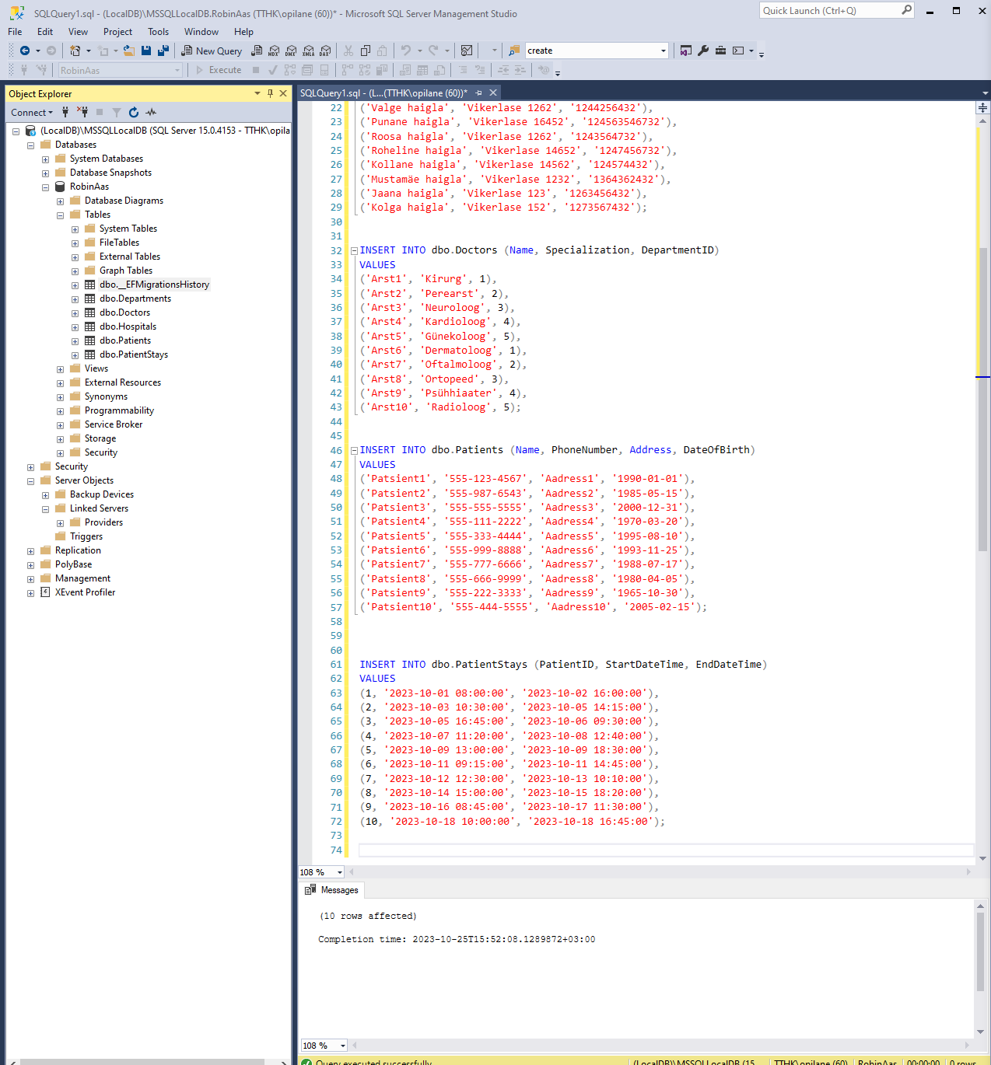

Stored Procedure:

CREATE PROCEDURE GetPatientsByHospital

@HospitalID INT

AS

BEGIN

SELECT P.*

FROM Patients AS P

INNER JOIN Departments AS D ON P.PatientID = D.DepartmentID

WHERE D.HospitalID = @HospitalID;

END;

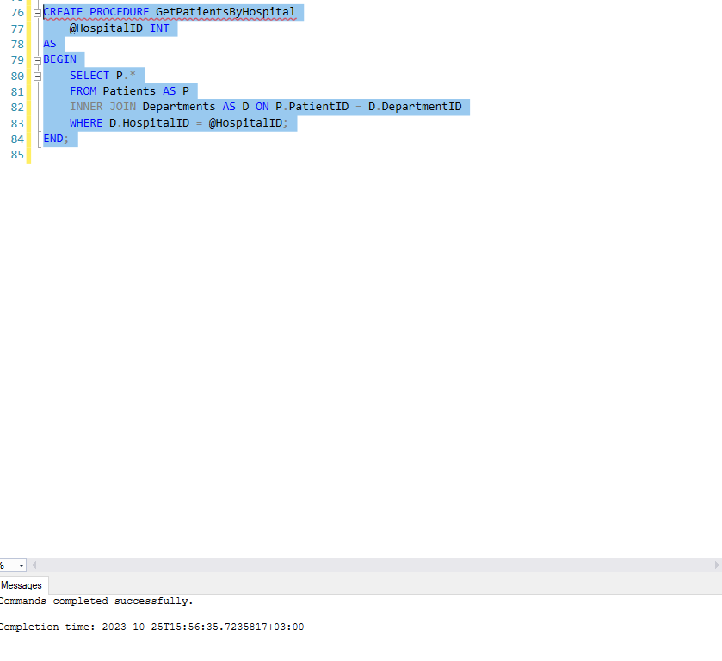

Väljakutsumine:

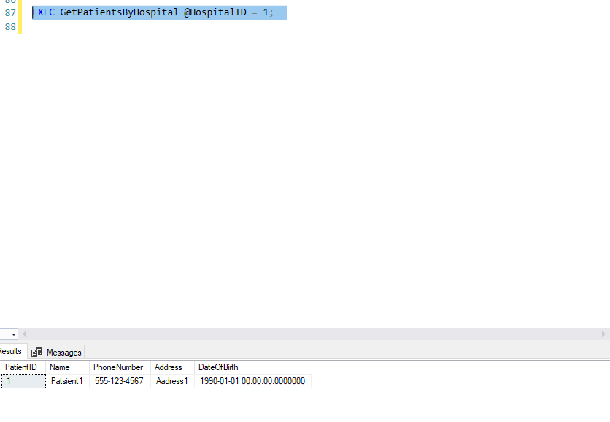

Joinid:

SELECT H.HospitalName, D.DepartmentName

FROM Hospitals AS H

INNER JOIN Departments AS D ON H.HospitalID = D.HospitalID;

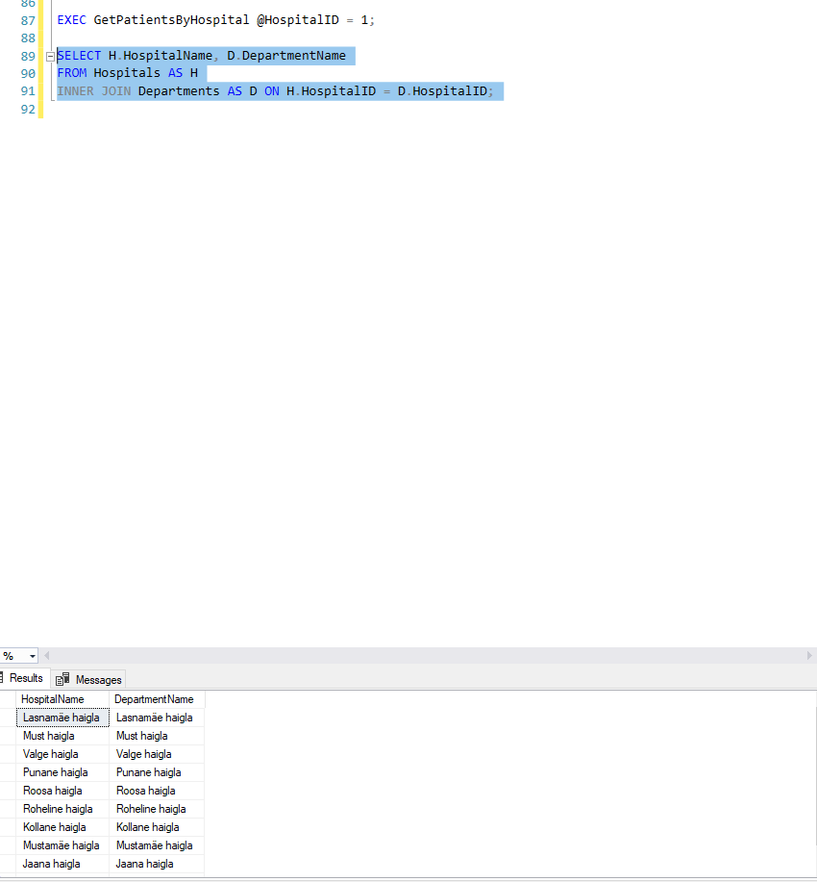

SELECT Departments.DepartmentName, Doctors.Name

FROM Departments

LEFT JOIN Doctors ON Departments.DepartmentID = Doctors.DepartmentID;

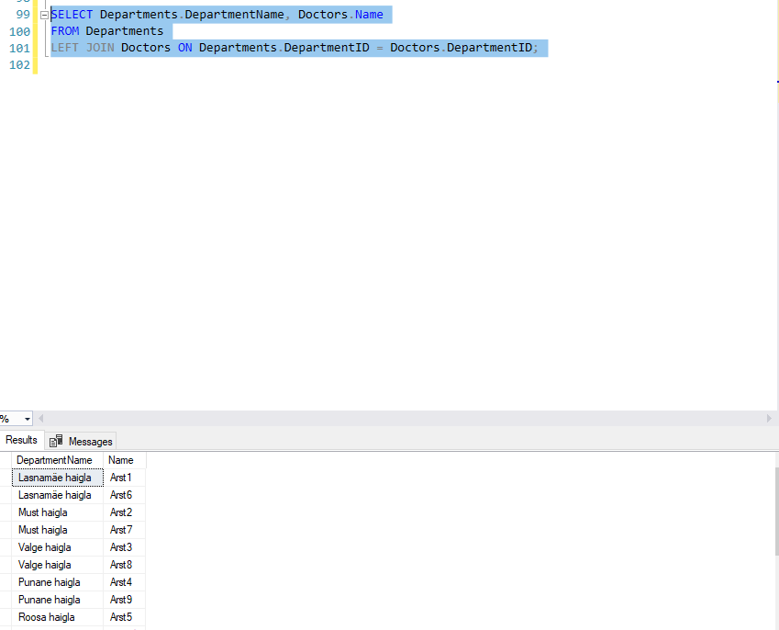

SELECT Doctors.Name AS DoctorName, Patients.Name AS PatientName, Hospitals.HospitalName

FROM Doctors

FULL JOIN Patients ON Doctors.DoctorID = Patients.PatientID

FULL JOIN Departments ON Doctors.DepartmentID = Departments.DepartmentID

FULL JOIN Hospitals ON Departments.HospitalID = Hospitals.HospitalID;

